Oop hometask 3
Sameer arhad 25f-0006
Question 1=
#include<iostream>
#include<string>
using namespace std;
class student
{
private:
string name;
int roll_no;
public:
static int nextroll_no;
student(string n)
{
++nextroll_no;
roll_no = nextroll_no;
cout << "NAME : " << n << " " << "roll no : " << roll_no << endl;

}
};
int student::nextroll_no = 0;
int main()
{
student s1("ali");
student s2("sameer");
student s3("shahryar");
}
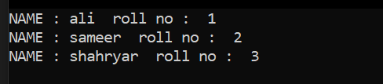
Question 2=
#include<iostream>
#include<string>
using namespace std;
class employee
{
private:
string name;
int salary;
public:
static int total_salary;
employee( string z,int n)
{
salary = n;
total_salary += salary;

}
~employee()
{
total_salary -= salary;
}
void display()
{

cout << "name :" << name << " " << "salary= " << total_salary << endl;

}

};
int employee::total_salary ;
int main()
{
employee e1("ali", 10000);
employee e2("sameer", 20000);
employee e3("sherry", 30000);
e1.display();
e2.display();
e3.display();

}
Output=
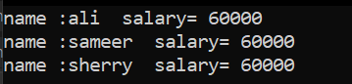

Question 3=
#include<iostream>
#include<string>
using namespace std;
class book
{

public:
string title;
static int bookcount;
book()
{
title = "unknown";
bookcount++;
}
void display()
{
cout << "total books created are " << bookcount<<endl;
}

};
int book::bookcount = 0;
int main()
{
book b[5];
b[0].display();
}
Output=
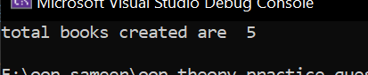
Question 4=
#include<iostream>
#include<string>
using namespace std;
class cars
{
private:
string model;
public:
static int carcount;
cars(string m)
{
model = m;
carcount++;
}
void display()
{
cout << "total cars are " << carcount << endl;
}
};
int cars::carcount = 0;
int main()
{
cars* c1 = new cars("toyota");
cars* c2 = new cars("honda");
cars* c3 = new cars("kia");
c1->display();
delete c1;
cout << "the remaining count are " << cars::carcount;
delete c2;
delete c3;

}
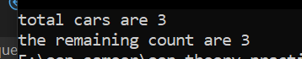
Question 4=
#include<iostream>
#include<string>
using namespace std;
class cars
{
private:
string model;
public:
static int carcount;
cars(string m)
{
model = m;
carcount++;
}
void display()
{
cout << "total cars are " << carcount << endl;
}
};
int cars::carcount = 0;
int main()
{
cars* c1 = new cars("toyota");
cars* c2 = new cars("honda");
cars* c3 = new cars("kia");
c1->display();
delete c1;
cout << "the remaining count are " << cars::carcount;
delete c2;
delete c3;

}
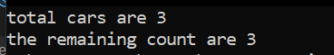
Question 5=
#include<iostream>
#include<string>
using namespace std;
class account
{
private:
string name;
int balance;
public:
int static totalcounts ;
account(string n,int y)
{
name = n;
balance = y;
totalcounts++;
}
~account()
{
cout << "account closed" << endl;
}
};
int account::totalcounts = 0;
int main()
{
account* a1 = new account("ali", 1000);
account* a2 = new account("sherry", 2000);
delete a1;
delete a2;

}
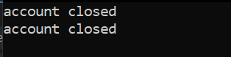
Question 6=
#include<iostream>
#include<string>
using namespace std;
class account
{
private:
string name;
int balance;
public:
static int intrest_rate;
account(string m,int n)
{
name = m;
balance = n;
}
void calculate()
{
double interest = ((intrest_rate)*balance )/ 10;
cout << "name :" << name << " " << "yearly interest rate: " << interest << endl;
}

};
int account::intrest_rate=5;
int main()
{
account a1("ali", 10000), a2("sherry", 20000), a3("simsim", 30000);
a1.calculate();
a2.calculate();
a3.calculate();

}
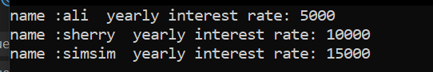
Question 7=
#include<iostream>
#include<string>
using namespace std;
class student {
private:
string name;
int marks;
public:
static int totalbooks;
student(string m, int n)
{
name = m;
marks = n;
totalbooks++;
cout<<"construtorr incremented "<<endl;
}
~student()
{
totalbooks--;
cout << "destructor decremented" << endl;
}

};
int student::totalbooks = 0;
int main()
{
student* s1 = new student("ali", 56);
student* s2 = new student("sameer", 40);
student* s3 = new student("sherry", 67);
delete s1;
delete s2;
delete s3;

}
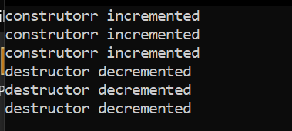
Question 8=
#include<iostream>
#include<string>
using namespace std;
class student
{
private:
string name;
int marks;
public:
static int studentcount;
student(string m, int n)
{
name = m;
marks = n;
studentcount++;
}
void display()
{
cout << "name :" << name << " " << "marks : " << marks << endl;

}
};
int student::studentcount = 0;
int main()
{
student* s[3];
s[0] = new student("ali ", 55);
s[1] = new student("sameer", 56);
s[2] = new student("sherry", 58);
for (int i = 0; i < 3; i++)
{
s[i]->display();
}

}
Output=
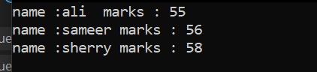
Question 9=
#include<iostream>
#include<string>
using namespace std;
class student
{
private:
string name;
int id;
public:
static int nextid;
static int studentcount;

student(string m)
{
id = ++nextid;
cout << id << " "<<m << endl;
studentcount++;

}
~student()
{
studentcount--;
}
};
int student::nextid = 0;
int student::studentcount = 0;
int main()
{
cout << "id " << " " << "name" << endl;
student* s[3];
s[0] = new student("ali");
s[1] = new student("sameer");
s[2] = new student("sherry");
cout << "total students "<<student::studentcount;
}
